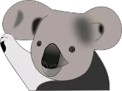
Create a Drawing
If you could be any

Draw a picture of the plant or animal
animal or plant in the world,
what would you be? _________________
__________________________________
__________________________________
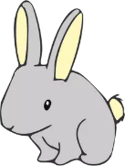
__________________________________

Where would you live? _____________
Draw a picture of where you would live
________________________________
________________________________
________________________________

What kinds of things would you need in your new home?
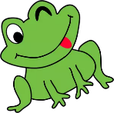
____________________ ____________________ ____________________ ____________________ ____________________ ____________________
What would you eat?
____________________ ____________________ ____________________

